**2.3 Eukaryotic cells**

**2.3.1.Draw and label a diagram of the ultrastructure of a liver cell as an example of an animal cell (1).**

Draw: To represent by means of pencil lines.  
  
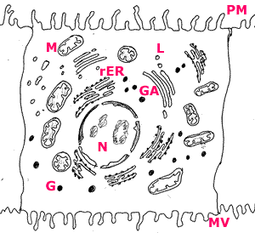

* N:Nucleus
* PM: plasma membrane
* M: mitochondria
* rER: Rough endoplasmic reticulum
* GA: Golgi apparatus
* L: Lysosome
* MV: Microvilli

**2.3.2 Annotate the diagram from 2.3.1 with the functions of each named structure.**

Annotate: to add brief notes to a diagram or graph.

**Nucleus:**This is the largest of the organelles. The nucleus contains the chromosomes which during interphase are to be found the nucleolus.

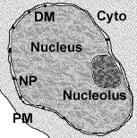

* The nucleus has a double membrane with pores(NP).
* The nucleus controls the cells functions through the expression of genes.
* Some cells are multi nucleated such as the muscle fibre

**Plasma membrane:**controls which substances can enter and exit a cell. It is a fluid structure that can 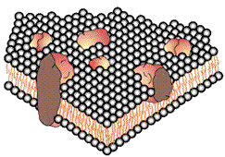radically change shape. see 2.4

* The membrane is a double layer of water repellant molecules.
* Receptors in the outer surface detect signals to the cell and relay these to the interior.
* The membrane has pores that run through the water repellant layer called channel proteins.

**Mitochondria**: location of aerobic respiration and a majot synthesis of ATP region..

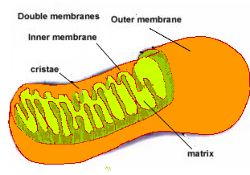

* Double membrane organelle.
* Inner membrane has folds called cristae. This is the site of oxidative phosphorylation.
* Centre of the structure is called the matrix and is the location of the Krebs cycle.
* Oxygen is consumed in the synthesis of ATP on the inner membrane
* The more active a cell the greater the number of mitochondria.

**Rough endoplasmic reticulum** (rER): protein synthesis and packaging into vesicles.

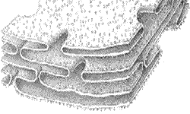

* rER form a network of tubules with a maze like structure.
* In general these run away from the nucleus
* The 'rough' on the reticulum is caused by the presence of ribosomes.
* Proteins made here are secreted out of the cell

**Ribosomes:** the free ribosome produces proteins for internal use within the cell.

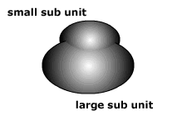

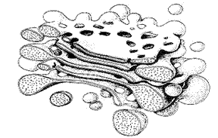 **Golgi apparatus:** modification of proteins prior to secretion.

* proteins for secretion are modified
* possible addition of carbohydrate or lipid components to protein
* packaged into vesicles for secretion

**Lysozyme:**

* Vesicles in the above diagram that have formed on the golgi apparatus.
* Containing hydrolytic enzymes.
* Functions include the digestion of old organelles, engulfed bacteria and viruses.

**2.3.3 Identify structures from 2.3.1 in electron micrographs of liver cells.(2)**

Identify: To find an answer from a given number of possibilities.

To identify structures within an electron micrograph it is necessary to know the scale at which the image has been taken. Look around the image to find the nucleus and then the mitochondria. In a plant cell there will also be the cell wall, chloroplasts and the vacuole to identify.

**Nucleus:**

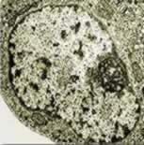In an electron micrograph the nucleus will be the largest of the organelles.

In this image there is a dark stained region called the nucleolus which is the location of the DNA.

The membrane has pores which allow the entry of cell signal molecules, nucleotides and the exit of mRNA.

Generally the nucleus appears spherical however there are cells in which the nucleus has more unusual shape such as the multi-lobbed white blood cells.

**Plasma membrane:**

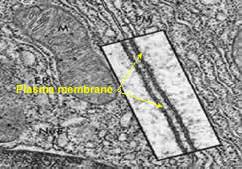

This image shows the junction between two liver cells. The image has been manipulated for clarity to see the two adjoining plasma membranes.

Notice the mitochondria to the left and the rER to the right of the membranes.

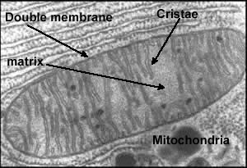**Mitochondria:**

This micrograph of a mitochondria shows:

* Double outer membrane
* Folded inner membrane called the cristae.
* Matrix of the mitochondria

These features are common to all mitochondria. Notice the rER above the mitochondria for scale and the dark granules of glycogen below the organelle.

**Endoplasmic reticulum (rER).**

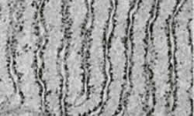The rER runs vertical in the image. Note the dark spots which are the ribosomes.

* A cell with a great deal of rER is producing proteins for secretion outside of the cell.
* The network of endoplasmic tubules allows proteins to be moved around within the cytoplasm before final packaging and secretion.

**Golgi apparatus:**

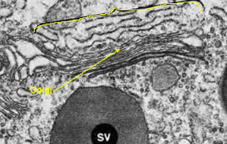The golgi apparatus in the diagram forms a stack of membrane envelopes on top of each other.

* Vesicles containing proteins fuse with the structure.
* The proteins are modified inside the apparatus usually with the addition of non-protein substances.

**Lysosome:**

* simple membrane bound vesicle containing hydrolytic enzymes
* produced in the golgi apparatus.
* used to digest engulfed bacteria or viruses or old organelles
* used to digest macromolecules
* hydrolytic enzymes are retained within the vesicle membrane to prevent autodigestion of the cell.

**2.3.4 Comparison of prokaryotic and eukaryotic cells (3).**

Compare means to give an account of similarities and differences between two (or more) items, referring to both (all) of them throughout.

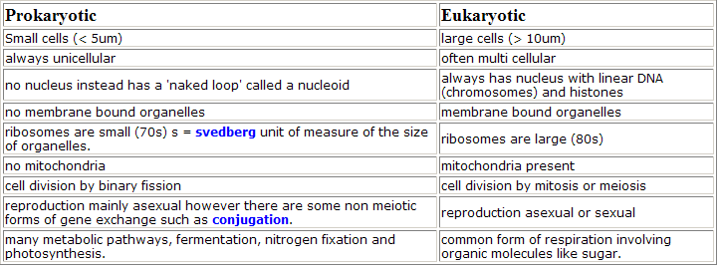

**2.3.5 State three differences between plant and animal cells (1).**

State:means to give a specific name, value or other brief answer without explanation or calculation.

Only three differences from this list are required.

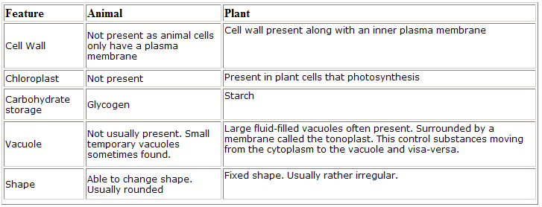

**2.3.6 Outline two roles of extracellular components(3).**

Outline means to give a brief account or summary.

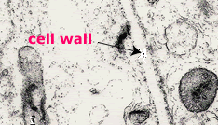a) Plant cell wall.

* Found around all plant cells
* Composed of cellulose.
* Maintains the shape of the cell.
* Provides structural support against the force of gravity.
* prevents excessive uptake of water by the cell

b) Animal extracellular matrix

i) Basement membrane: a secretion formed from collagen and glycoproteins joined together by a third 'linkage' protein. Their exact composition varies form tissue to tissue.

**Support:**the membrane surrounds the tissues of [lines ducts](http://www.bu.edu/histology/p/16103loa.htm). It provides structural support for the integrity of the tissue or organ. Usually found as the basal lamina or basement membrane of epithelial cells.

**Filter :** The [basement membrane](http://missinglink.ucsf.edu/lm/IDS_101_histo_resource/images/329Bx10_copy.jpg) of the kidney glomerulus provides the effective barrier for ultrafiltration

**Vascular niche**: Interestingly cells often require a base on which to organise before they will form proper tissue. There are implications here for developmental biology, tissue repair, stem cell therapies and cancer treatment.

ii) Interstitial matrix:

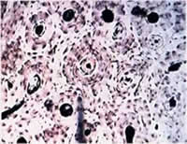

**Bone** has a matrix which includes collagen with a calcium phosphate.

Other tissues are surrounded by a matrix composed of a kind of gel that provides support for the tissue.